8 December 2010

LTER 2010 GIS Survey Results

This is a summary of the results of the GIS survey. All 26 LTER sites responded. There is also an Excel file with the complete answers.

Note that the numbers in the answers to the questions may not always add up to 26; this is because many sites use multiple technologies. Additionally, when a response didn’t include the software version number for ESRI products, version 9 was assumed.

Site | GIS person |  | contact email
AND | Theresa Valentine |  | Theresa.valentine@oregonstate.edu or  tvalentine@fs.fed.us
ARC | Jason Stuckey |  | j.stuckey@alaska.edu
BES | Jonathon Walsh & 3+ others |  | walshj@caryinstitute.org
BNZ | Jamie Hollingsworth |  | jhollingsworth@alaska.edu
CAP | PhD student |  | ptarran@asu.edu
CCE | <none> |  | kbaker@ucsd.edu
CDR | Dan Bahauddin |  | danbaha@umn.edu
CWT | John Chamblee |  | chamblee@uga.edu
FCE | Mike Rugge |  | ruggem@fiu.edu
GCE | Travis Douce |  | tdouce@uga.edu
HBR | John Campbell |  | jlcampbell@fs.fed.us
HFR | Brian Hall |  | brhall@fas.harvard.edu
JRN | Barbara Nolen |  | bnolen@nmsu.edu
KBS | Suzanne Sippel |  | sippel@kbs.msu.edu
KNZ | Adam Skibbe |  | askibbe@ksu.edu
LUQ | Mei Yu |  | meiyu@ites.upr.edu
MCM | <none> |  | welch.318.osu.edu
MCR | <none> |  | gastil@msu.ucsb.edu
NTL | Aaron Stephenson |  | ajstephenson@wisc.edu
NWT | Hope Humphries |  | hope.humphries@colorado.edu
PAL | <none> |  | kbaker@ucsd.edu
PIE | various people |  | hgarritt@mbl.edu
SBC | <none> |  | mob@icess.ucsb.edu
SEV | Mike Friggins |  | friggens@sevilleta.unm.edu
SGS | Robert Flynn |  | robert.flynn@.colostate.edu
VCR | John Porter |  | jporter@lternet.edu
Question 1
Do you have a person responsible for GIS data at your LTER? What percentage of their time do they work with GIS? Give the name and email address of the person.

The amount of time spent on GIS work varies greatly between LTER sites. Most of the percentages given are estimates and some are approximate totals of multiple people at a site. Five sites don’t have a person responsible for GIS data. Of the sites that responded, most have someone responsible for GIS data, but they spend very little time with it. Only a few sites have dedicated GIS personnel.

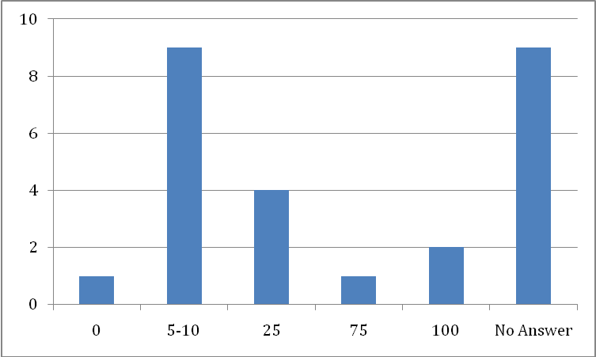
Question 2
What GIS software do you use at your site?

All sites use ArcGIS version 9 or 10 except for CCE, PAL and SBC who don’t use GIS.
CCE and PAL use geospatial software applications such as satellite image processing packages IDL and Matlab.
MCR- Moorea Island does not allow disclosure of research locations so their use of GIS is somewhat limited.
Other GIS software used in addition to ArcGIS: Idrisi (PIE) , QuantumGIS (KBS, NTL & PIE), GRASS GIS (PIE), RiverGIS (PIE), ERDAS Imagine 8 (CWT, VCR), MapWindow GIS (CWT), ArcView 3.3(FCE), GDAL (KBS), uDIG (NTL), Definiens (PIE), ArcPad (SEV), Google Earth and Google Maps.

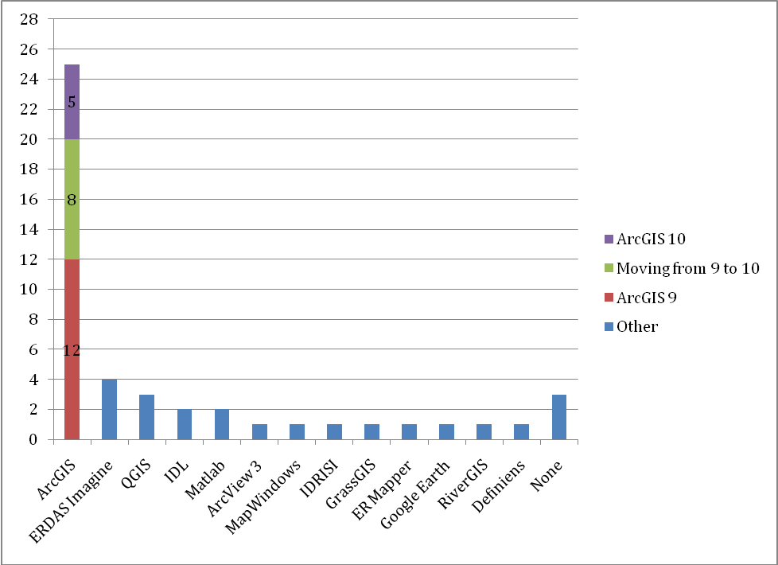
Question 3
What file formats does your site use for vector data?

LTER sites use a combination of the following formats: shapefiles, coverages, ArcSDE, personal geodatabases, file-based databases, KML, PostGIS and well-known text. The format used most commonly is the shapefile (19 sites), while 20 sites use one of more of the geodatabase formats (ArcSDE, personal and file-based).
Shapefiles- 19 sites; 6 of these use shapefiles exclusively
ArcSDE; 8 sites
File-based geodatabase; 7 sites
Personal geodatabase; 5 sites
Coverages- 4 sites; 1 site uses coverages exclusively
KML; 1 site use this for public viewing
PostGIS; 1 site is moving to this
Well-known text; CCE and PAL use this format in order to be compatible with a number of geospatial applications. They only have a limited amount of vector data. Arc Export format; 1 site uses this for posting data on the web.
Several sites mentioned that they are moving to one of these formats: geodatabase, file-based geodatabase, SDE and PostGIS.

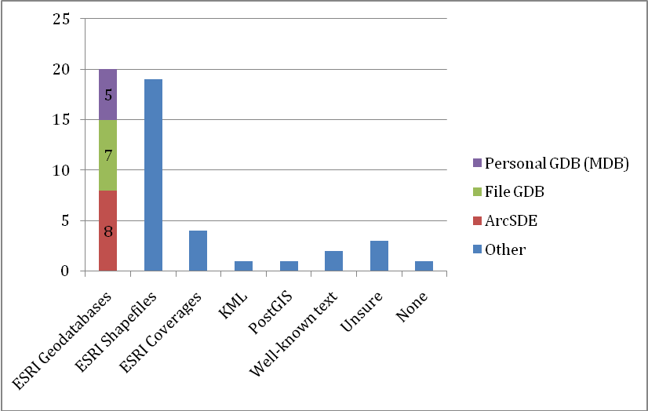
Question 4
What format does your site use for raster data?

The two most common raster file formats used by the LTER sites are ESRI grids (13 sites) and Erdas Imagine (.img) files (10 sites). Geotiffs (4 sites) and tiffs (6 sites) are also very common. The following formats are used by one or two sites: Mr. Sid (2), JPG (2), JGP2 (1), ECW (1), SDR (1), LAN (1), ASCII (1), RST (1). HDF & Net CDF are used for satellite data by two sites.

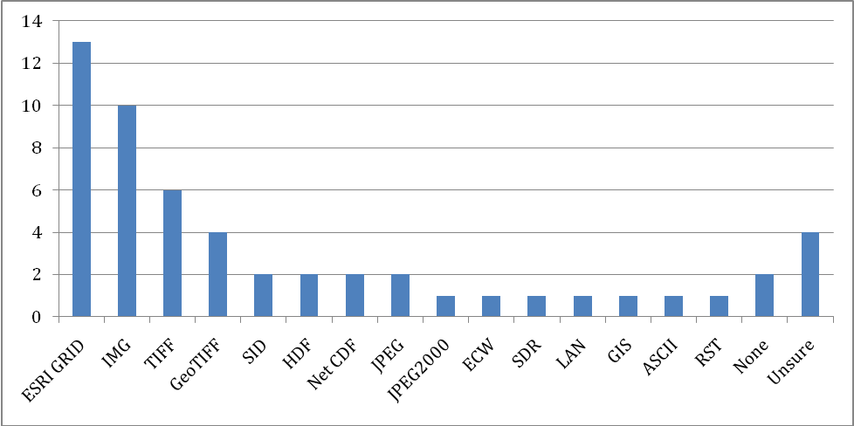

Question 5
Do you use a spatial database? If so, what software and version does your site use?

15 sites use a spatial database. 10 sites are using ArcSDE (5 use it on SQL Server, 3 on Oracle, 2 didn’t say; Note that for sites that only answered with an RDBMS and not spatial middleware, ArcSDE 9 was assumed for Oracle and SQL Server, and PostGIS was assumed for PostgreSQL).
Of the sites that said what Relational Database Management System (RDBMS) underlies their spatial database, 5 use a version of SQL Server (versions 2000, 2005, and 2008 were mentioned), 3 use Oracle (all version 10g), 3 use PostgreSQL, and 1 uses mSQL.

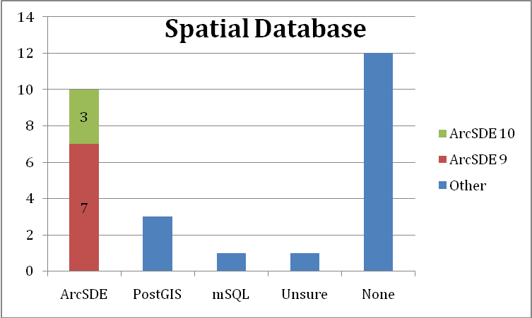

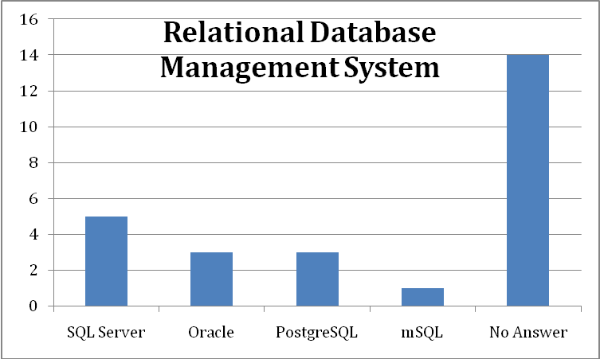
Question 6
Does your site use GIS server software for either web mapping or hosting data services?

17 sites are using GIS server software and most are using ArcGIS Server. AND, BNZ, HFR, JRN, MCM, NTL, SEV and SGS presently use ArcGIS Server for web mapping and some also use it for hosting KML services, however, NTL plans to move to GeoServer. FCE and VCR use MapServer. KBS has tried both MapServer and GeoServer. AND, CWT, and KNZ all use ArcIMS, although not for much longer.

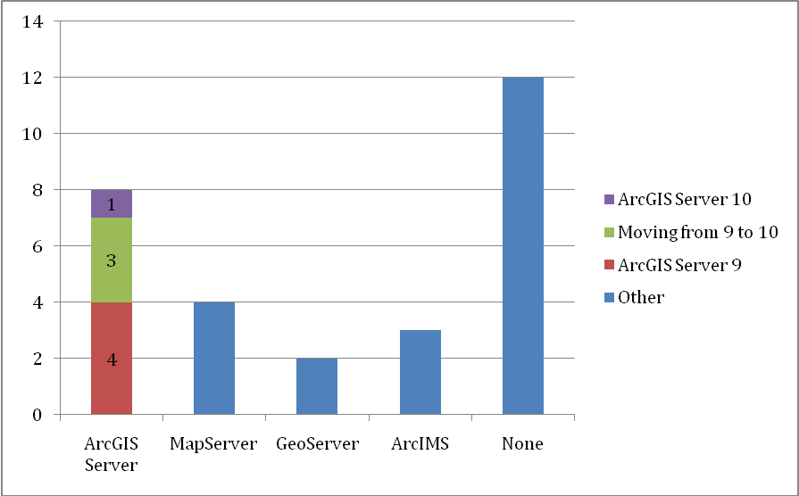

Question 7
Does your site have a functional internet mapping site? If so, include the link. What platform and API was it developed on?

Fourteen sites presently have an internet mapping site.

Site | Web Address | Platform & API
AND | http://andrewsforest.oregonstate.edu/data/iamap.cfm?topnav=101 | ArcIMS
ARC | http://www.gina.alaska.edu/information/system-architecture/ | MapServer
BES | http://his09.umbc.edu/dash/ | ArcGIS Server, .NET ADF
BNZ | http://ltergis.iab.uaf.edu/bnzmap/ | ArcGIS Server, .NET ADF
CAP | http://caplter.asu.edu/research/research-area-map/ | Google Maps
CWT | http://cogent.uga.edu/ | ArcIMS
FCE | http://fcelter.fiu.edu/data/GIS/interactive_map/ | MapServer+Gmap
GCE | http://gce-lter.marsci.uga.edu/public/gis/gcewebmap.html | Google Maps
HFR | http://hfapps.fas.harvard.edu/HF1830_Map/ | ArcGIS Server, .NET ADF
JRN | http://jornada-vgis.nmsu.edu:8399/JornadaBaseMap | ArcGIS Server, Java ADF
MCM | http://www.mcmlter.org/mapping.htm | ArcGIS Server, Java ADF
NTL | http://lter.limnology.wisc.edu/spatial2/spatial.html | ArcGIS Server Java ADF
SGS | http://sgslter.colostate.edu/maps.aspx | ArcGIS Server, .NET ADF
VCR | http://amazon.evsc.virginia.edu/home1/?q=OnlineMaps | Mapserver
Question 8
Does your site use ESRI Image Server?

AND and JRM are the only sites that have image server running.
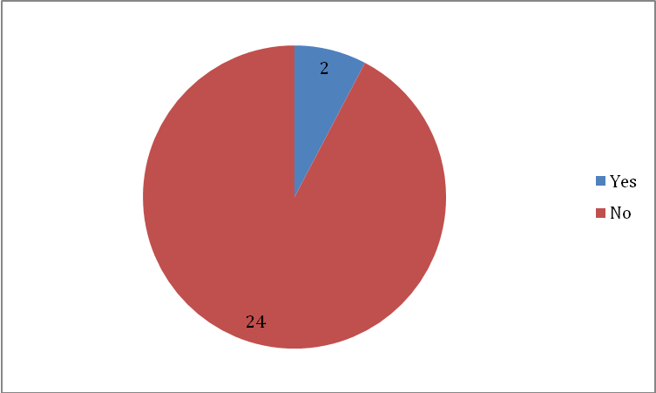

Question 9
Do you have a GPS that collects data at appropriate resolution for you sites needs?

Twenty sites do have a GPS at appropriate resolution for their sites needs although several of these sites mentioned that they could use improved resolution or features. The other six sites either borrow a GPS or don’t have one to serve their needs.

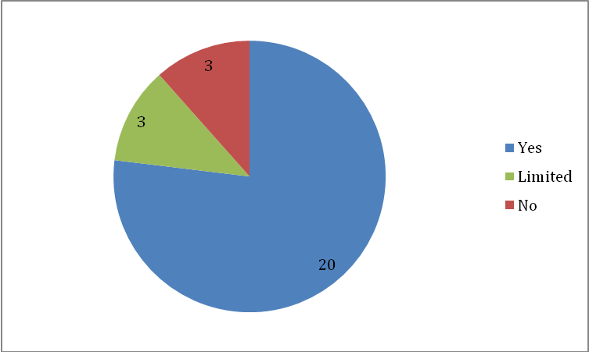

Question 10
Do you have Lidar data available at the appropriate resolution for your site?

Eight sites (AND, BES, GCE, HFR, KBS, KNZ, NWT, VCR) have Lidar data at the appropriate resolution for their site. Five sites (ARC, BNZ,CWT, FCE, SBC) have some Lidar data but it isn’t at the best resolution or they would like additional areas covered. MCM does have some Lidar data but resolution and coverage were not given. The remaining 12 sites don’t have Lidar data. Some of these sites are very interested in obtaining Lidar data and a couple mentioned that it is a lower priority because their sites are completely underwater or focus on aquatic systems.

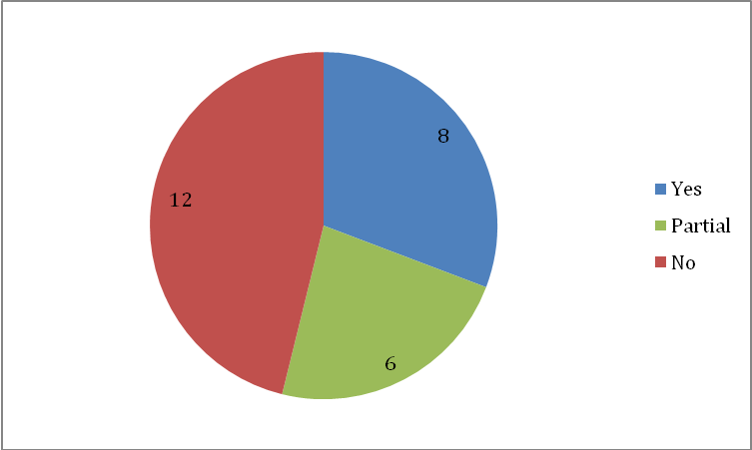

Question 11
Would your IM manager be interested in a GIS introductory short (3-day) course?

Five of the LTER sites said their IM manager or someone else would be interested in such a course and 5 more sites said they might be interested depending on the focus and level of the course. 16 sites said they would not be interested; several mentioned that their IM manager already has GIS training. There probably are not enough sites interested in a course with the same focus and level of GIS experience.

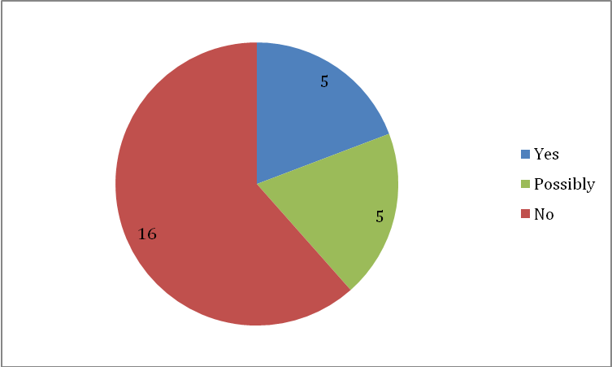

Question 12
Do you have any GIS/remote sensing training needs?

Thirteen sites noted that they might be interested in GIS/remote sensing training and listed the following topics that would be useful to them:
- Modeling
- Working with java script API (coincidently, this API will be used by LTERMaps)
- Using SQL Server databases with GIS data
- SDE/Oracle administration
- Python scripting with ArcGIS
- ArcGIS geodatabases
- Geodata services
- ERDAS Photogrammetry Suite
- Rectification and management of remotely sensed data (satellite imagery and airphotos)
- GIS training
- Advanced ArcGIS Server training
- CWT said they would like to provide a short course for the graduate students at the start of each summer's field season that they would do themselves and it would be helpful to have a set of training *material* prepared, especially one that spoke to spatial data standards and protocols.

